UNIT 3
Android

3.1 Introduction to Android
Android is an open source and Linux-based Operating System for mobile devices such as smartphones and tablet computers. Android was developed by the Open Handset Alliance, led by Google, and other companies.
Android offers a unified approach to application development for mobile devices which means developers need only develop for Android, and their applications should be able to run on different devices powered by Android.
3.2 History of Android
The story of Android dates back to 2003 when Andy Rubin, Rich Miner, Nick Sears, and Chris White co-founded a start-up Android Inc. in Palo Alto, California. However, the company was later faced with the insufficiency of funds which brought Google into the picture. Google could sense the potential the product carried within and sealed a deal worth $50 Million to acquire Android in 2005. All the four Co-founders soon moved to the Googleplex to continue to develop the OS further under their new owners. The first public Android Beta Version 1.0 was finally published on 5th November 2007.
The code names of android ranges from A to P currently, such as Aestro, Blender, Cupcake, Donut, Eclair, Froyo, Gingerbread, Honeycomb, Ice Cream, Sand witch, Jelly Bean, Kit Kat, Lollipop, Marshmallow, Nougat and Pie. Let's understand the android history in a sequence.
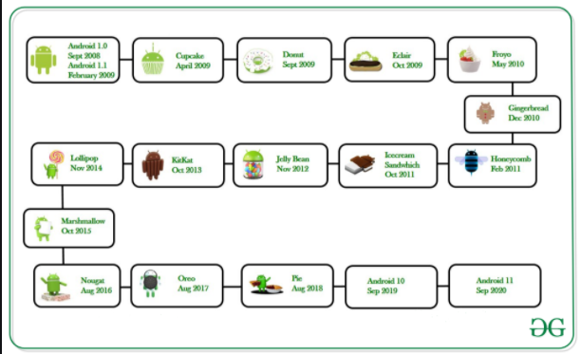

3.2 Android version and its features
The development of the Android operating system was started in 2003 by Android, Inc. Later on, it was purchased by Google in 2005. The beta version of Android OS was released on November 5, 2007, while the software development kit (SDK) was released on November 12, 2007. The first Android mobile was publicly released with Android 1.0 of the T-Mobile G1 (aka HTC Dream) in October 2008. Google announced in August 2019 that they were ending the confectionery scheme, and they use numerical ordering for future Android versions.
The first Android version which was released under the numerical order format was Android 10.
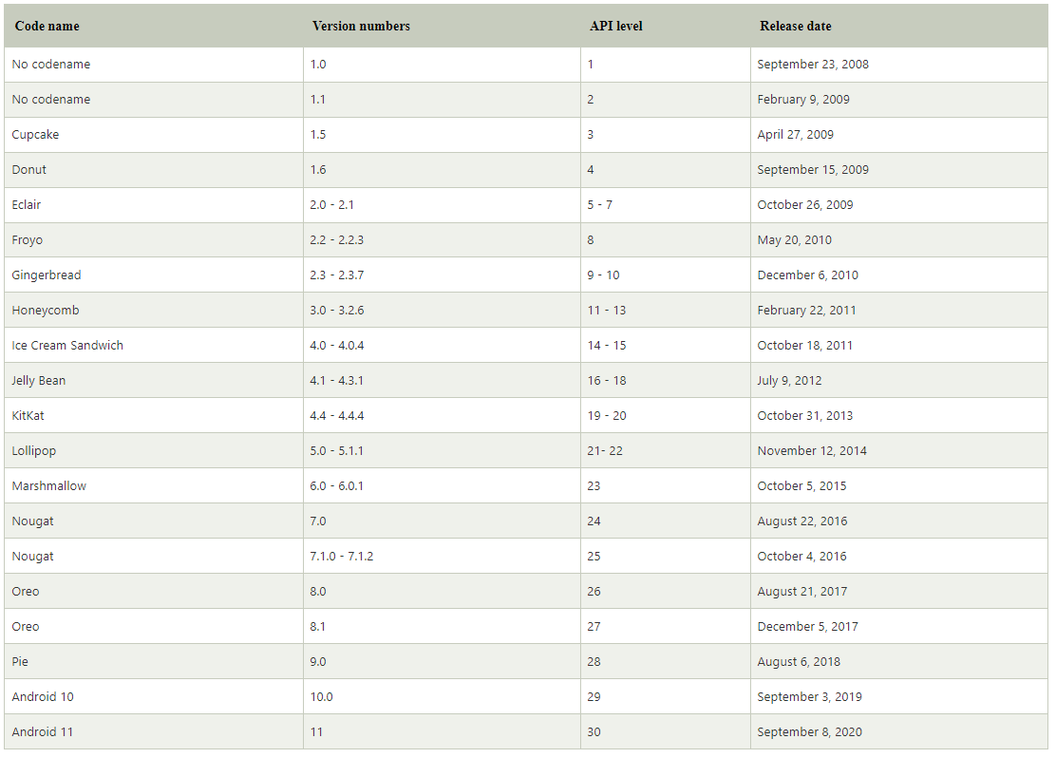

Features of android
After learning what is android, let's see the features of android. The important features of android are given below:
- It is open source.
- Anyone can customize the Android Platform.
- There are a lot of mobile applications that can be chosen by the consumer.
- It provides many interesting features like weather details, opening screen, live RSS (Really Simple Syndication) feeds etc.
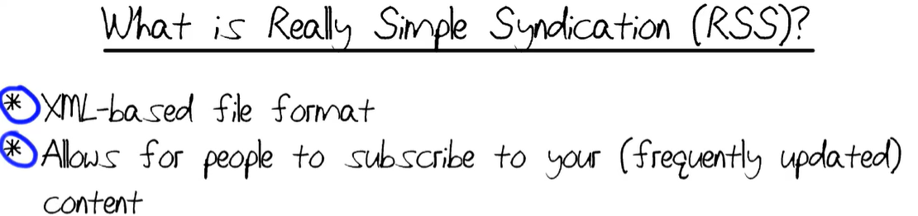
them are listed below −
S.N. | Feature & Description
1 | Beautiful UI  Android OS basic screen provides a beautiful and intuitive user interface.
2 | Connectivity  GSM/EDGE, IDEN, CDMA, EV-DO, UMTS, Bluetooth, Wi-Fi, LTE, NFC and WiMAX.
3 | Storage  SQLite, a lightweight relational database, is used for data storage purposes.
4 | Media support  H.263, H.264, MPEG-4 SP, AMR, AMR-WB, AAC, HE-AAC, AAC 5.1, MP3, MIDI, Ogg Vorbis, WAV, JPEG, PNG, GIF, and BMP.
5 | Messaging  SMS and MMS
6 | Web browser  Based on the open-source WebKit layout engine, coupled with Chrome's V8 JavaScript engine supporting HTML5 and CSS3.
7 | Multi-touch  Android has native support for multi-touch which was initially made available in handsets such as the HTC Hero.
8 | Multi-tasking  User can jump from one task to another and same time various application can run simultaneously.
9 | Multi-Language  Supports multi-language.
10 | GCM  Google Cloud Messaging (GCM) is a service that lets developers send short message data to their users on Android devices, without needing a proprietary sync solution.
11 | Wi-Fi Direct  A technology that lets apps discover and pair directly, over a high-bandwidth peer-to-peer connection.
12 | Android Beam  A popular NFC-based technology that lets users instantly share, just by touching two NFC-enabled phones together.

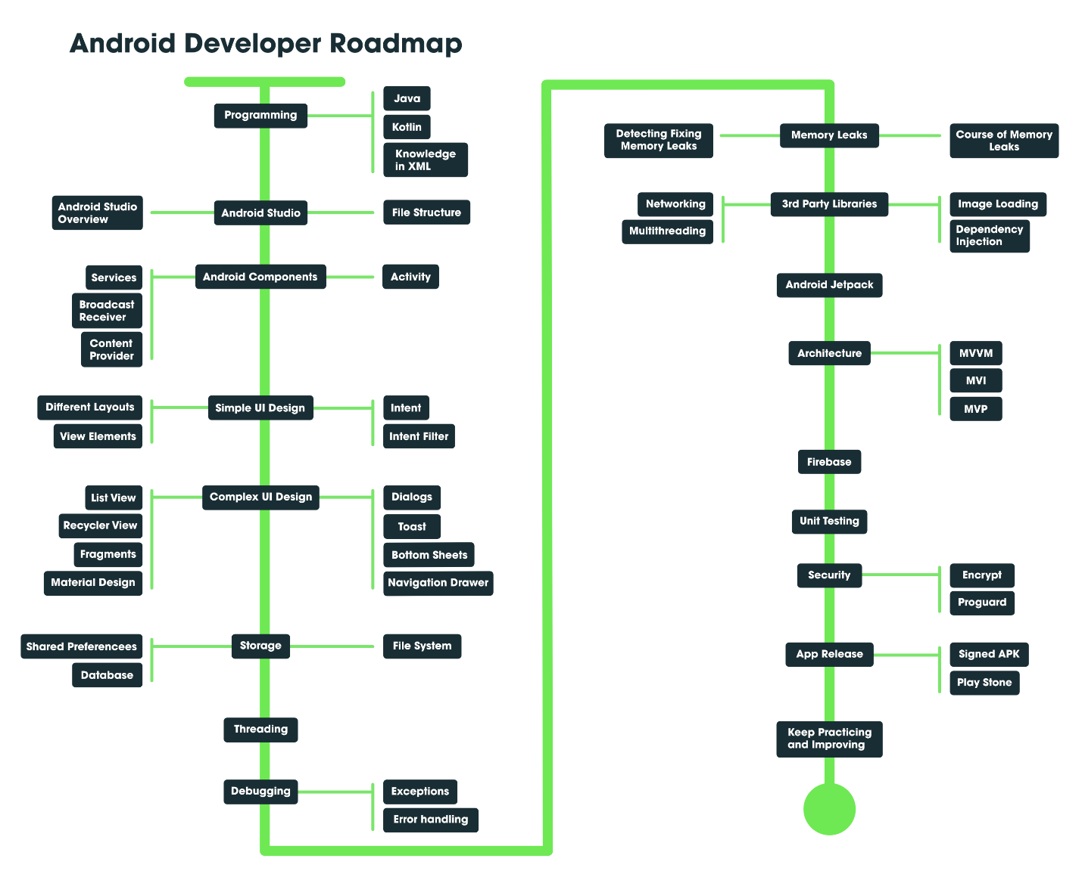

3.3 Working mechanism of android
Android architecture or Android software stack is categorized into five parts:
- linux kernel
- native libraries (middleware),
- Android Runtime
- Application Framework
- Applications

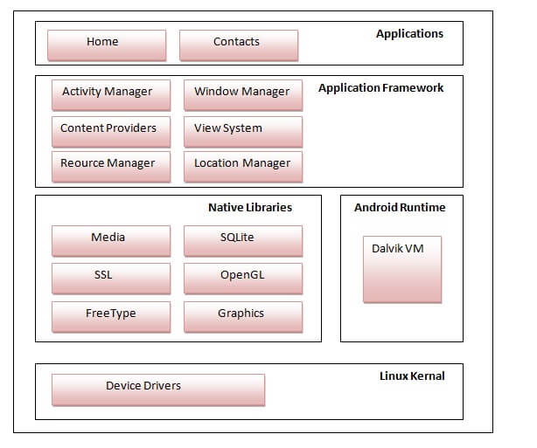
Fig: android architecture
1) Linux kernel
It is the heart of android architecture that exists at the root of android architecture. Linux kernel is responsible for device drivers, power management, memory management, device management and resource access.
2) Native Libraries
On the top of linux kernel, there are Native libraries such as WebKit, OpenGL, FreeType, SQLite, Media, C runtime library (libc) etc. The WebKit library is responsible for browser support, SQLite is for database, FreeType for font support, Media for playing and recording audio and video formats.
3) Android Runtime
In android runtime, there are core libraries and DVM (Dalvik Virtual Machine) which is responsible to run android application. DVM is like JVM but it is optimized for mobile devices. It consumes less memory and provides fast performance.
4) Android Framework
On the top of Native libraries and android runtime, there is android framework. Android framework includes Android API's such as UI (User Interface), telephony, resources, locations, Content Providers (data) and package managers. It provides a lot of classes and interfaces for android application development.
5) Applications
On the top of android framework, there are applications. All applications such as home, contact, settings, games, browsers are using android framework that uses android runtime and libraries. Android runtime and native libraries are using linux kernal.

3.4 Android development toolkit
Android software development is the process by which applications are created for devices running the Android operating system. Google states that "Android apps can be written using Kotlin, Java, and C++ languages" using the Android software development kit (SDK), while using other languages is also possible. Third party tools, development environments, and language support have also continued to evolve and expand since the initial SDK was released in 2008. The official Android app distribution mechanism to end users is Google Play; it also allows staged gradual app release, as well as distribution of pre-release app versions to testers.

The Android software development kit (SDK) includes a comprehensive set of development tools. The Android SDK Platform Tools are a separately downloadable subset of the full SDK, consisting of command-line tools such as adb and fastboot. The Android Debug Bridge (ADB) is a tool to run commands on a connected Android device. Fastboot is a protocol used for flashing file systems. Code written in C/C++ can be compiled to ARM, or x86 native code (or their 64-bit variants) using the Android Native Development Kit (NDK).

Some of the android development toolkits are:
1. Kotlin Programming Language
Android development first started using Java as their preferred language of development. In May 2019, Google announced Kotlin to be Android’s preferred language of development. Every new technology released since then by Google has been written in Kotlin.
Kotlin builds upon the foundation of improving the drawbacks of Java. It reduces the longwinded syntax and adds functionality that Java developers have complained about for multiple years. Kotlin’s concise syntax and robustness was the primary reason for the migration of Java developers to use Kotlin for development.
Kotlin is 100% interoperable with Java. In other words, Kotlin code can invoke and use Java classes and functions, and the other way around. You can have both Kotlin and Java code in the same codebase without any configuration costs. Old legacy code does not need to be fully replaced with Kotlin.
2. Android Studio
Android Studio is by far the most important tool you need for Android Development. It was created by both Google and JetBrains and it is very similar to IntelliJ IDEA. Android Studio is a specific IDE used by Android developers. This can also be used to develop cross-platform applications using Flutter.
Android Studio allows you to have multiple features relating to Android Development like:
a. Wireless Debugging: You can debug your applications on a physical device wireless, provided you are on the same network.
b. Preview: For Compose Applications, you can view the preview of the specific component you are building.
c. Sync with Android SDK: Android Studio has great synchronization with your system’s available SDK.
d. Built-in Gradle system: Android, being a JVM application, uses the Gradle build system. The UI allows for an easier interface to run commands.
e. Logcat: Your application does not work as intended. Debugging in Android is done using the system’s Logcat, an inbuilt window inside Android Studio.
f. Device Manager and Profiler: Building an Android application involves analyzing multiple application areas such as device usage, battery usage, memory usage, and more.
3. Firebase
Firebase is perhaps one of the best tools to use if you are not familiar with building backend API Servers. Firebase is a Google-run backend service that is free to use until a certain limit. This service includes databases, cloud storage, cloud functions, authentication, and more.
If you are creating an application that requires the user to be logged in, then Firebase would create an entire Authentication system by simply press a few buttons and write about 20 lines of code. Similarly with databases and cloud storage. Other features that Firebase offers are Crashlytics, ML kit, and Hosting (for web apps).
4. Jira
Oftentimes, you will be working in a team of developers. There would be ideas and bugs popping up every minute of development that need to be dealt with. Post-covid, most people don’t work at the same time and one cannot expect one person to fix all the bugs they spot.
JIRA is a great project management website that can be tailored to your needs and is used to track issues, plan projects and promote team collaboration. JIRA supports Agile development methodology and support features such as Agile Poker, Sprint cycles and much more. This tool shines in streamlining the development process and improves team communication.

